**Average temperature**

3. From the following link extract the weather data  
  
<https://github.com/tomwhite/hadoop-book/tree/master/input/ncdc/all>

Create a Map Reduce program to  
  
a) find average temperature for each year from NCDC data set.

AverageDriver

package temp;  
import org.apache.hadoop.fs.Path;  
import org.apache.hadoop.io.IntWritable;  
import org.apache.hadoop.io.Text;  
import org.apache.hadoop.mapreduce.Job;  
import org.apache.hadoop.mapreduce.lib.input.FileInputFormat;  
import org.apache.hadoop.mapreduce.lib.output.FileOutputFormat;  
  
public class AverageDriver {  
 public static void main(String[] args) throws Exception {  
 if (args.length != 2) {  
 System.err.println("Please Enter the input and output parameters");  
 System.exit(-1);  
 }   
 Job job = new Job();  
 job.setJarByClass(AverageDriver.class);  
 job.setJobName("Max temperature");  
 FileInputFormat.addInputPath(job, new Path(args[0]));  
 FileOutputFormat.setOutputPath(job, new Path(args[1]));  
 job.setMapperClass(AverageMapper.class);  
 job.setReducerClass(AverageReducer.class);  
 job.setOutputKeyClass(Text.class);  
 job.setOutputValueClass(IntWritable.class);  
 System.exit(job.waitForCompletion(true) ? 0 : 1);  
 }  
}

**AverageMapper**

package temp;  
import java.io.IOException;  
import org.apache.hadoop.io.IntWritable;  
import org.apache.hadoop.io.LongWritable;  
import org.apache.hadoop.io.Text;  
import org.apache.hadoop.mapreduce.Mapper;  
  
public class AverageMapper extends Mapper<LongWritable, Text, Text, IntWritable> {  
 public static final int MISSING = 9999;  
   
 public void map(LongWritable key, Text value, Mapper<LongWritable, Text, Text, IntWritable>.Context context) throws IOException, InterruptedException {  
 int temperature;  
 String line = value.toString();  
 String year = line.substring(15, 19);  
 if (line.charAt(87) == '+') {  
 temperature = Integer.parseInt(line.substring(88, 92));  
 } else {  
 temperature = Integer.parseInt(line.substring(87, 92));  
 }   
 String quality = line.substring(92, 93);  
 if (temperature != 9999 && quality.matches("[01459]"))  
 context.write(new Text(year), new IntWritable(temperature));   
 }  
}

**AverageReducer**

package temp;  
import java.io.IOException;  
import org.apache.hadoop.io.IntWritable;  
import org.apache.hadoop.io.Text;  
import or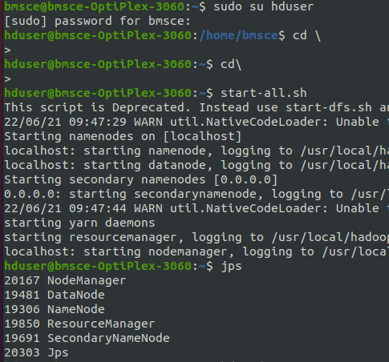g.apache.hadoop.mapreduce.Reducer;  
  
public class AverageReducer extends Reducer<Text, IntWritable, Text, IntWritable> {  
 public void reduce(Text key, Iterable<IntWritable> values, Reducer<Text, IntWritable, Text, IntWritable>.Context context) throws IOException, InterruptedException {  
 int max_temp = 0;  
 int count = 0;  
 for (IntWritable value : values) {  
 max_temp += value.get();  
 count++;  
 }   
 context.write(key, new IntWritable(max_temp / count));  
 }  
}

